CS224M- Assignment 2
Dimple Kochar- 16D070010

Q1.Run the simulation with the default parameters and answer the following questions.
- What is the average throughput of the TCP transfer? What is the maximum expected value of throughput? Is the achieved throughput approximately equal to the maximum expected value? If it is not, explain the reason for the difference.
- How many times did the TCP algorithm reduce the cwnd, and why?

On running tcp-example-1.0.pcap
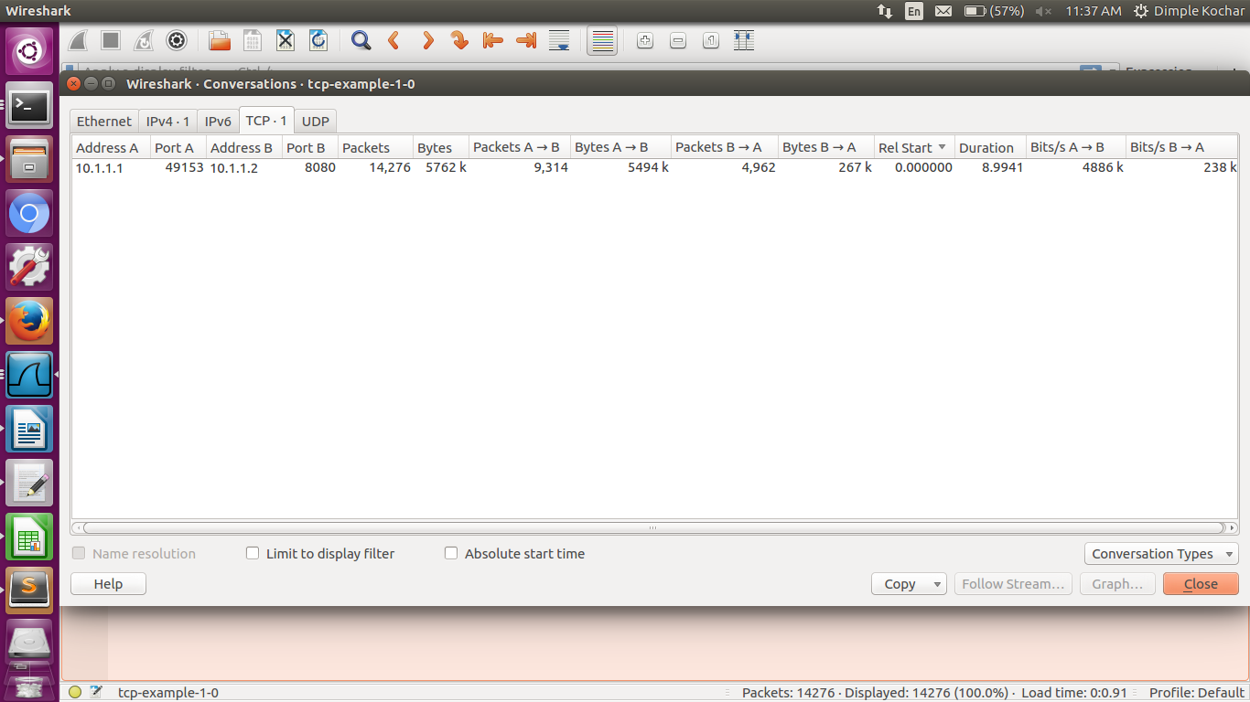

Average Throughput= 4.886Mbps

(OR)

On running tshark to get packet length
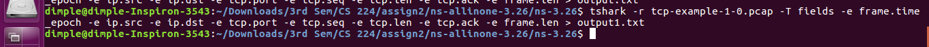

converted output1.txt to spreadsheet output1.ods (attached) and summed all the frame.len column (packet length received column) from 10.1.1.1 to 10.1.1.2=5494250 bytes
Subtracting the last and first time frame to get total time= 8.994145 sec
So throughput is= 5494250/8.994145=610.869KBps=4.886957 Mbps

Expected throughput (Bandwidth)=5Mbps
So, the achieved throughput is approximately equal to the maximum expected value.
The difference is due to the delay and packet losses in real life scenario.

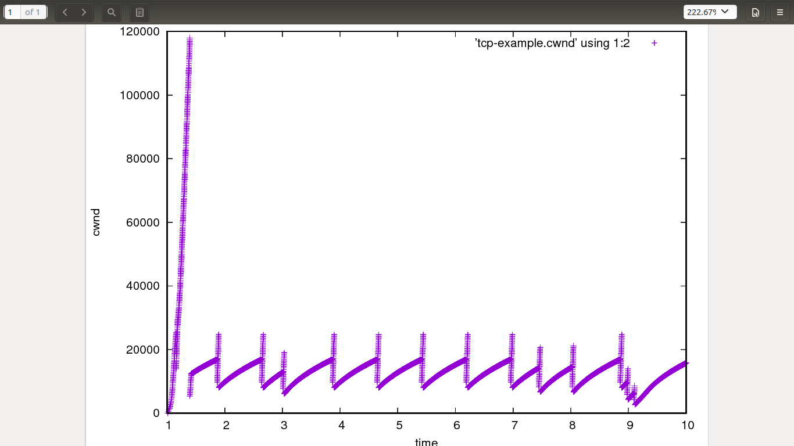
TCP reduced cwnd 14 times.
packet loss happens when window reaches W packets. At this
point, the bottleneck buffer and the pipe have both filled up and so
bottleneck router has dropped a packet. Let the size of bottleneck
buffer be B packets. Let the rate of bottleneck be R and end to end
delay on the path be D. Now BDP = R * D. And W = R * D + B.
Here, R=5Mbps D=5ms So, BDP=25000bits
Queue=10 Bottlenext buffer= 10* 1500*8=120000bits
Therefore, in the beginning, we get cwnd increasing to 120000 bits, due to the queue. Later, it's limited by BDP, so, whenever cwnd reaches ~25000bits, there's a packet loss and cwnd is halved.

[As long as there is space in cwnd, sender keeps sending TCP segments of size MSS.
Now, if we get 3 dupacks, we do fast retransmit of the lost segment. Along with it, we also do fast recovery. Fast recovery can be reached from slow start or congestion avoidance. Again, we set sshthresh = cwnd/2. However, we do not set cwnd all the way to 1 MSS. We set it to half the value where congestion occured. Thus this congestion avoidance is also called additive increase multiplicative decrease (AIMD). Finally, fast recovery ends after the loss has been recovered and we get a new ACK (not dupack). ]
So, we get this saw-tooth structure.

Q2. Start with the default config. Change the link bandwidth to 50Mbps (from 5 Mbps).
- What is the average throughput of the TCP transfer? What is the maximum expected value of throughput? Is the achieved throughput approximately equal to the maximum expected value? If it is not, explain the reason for the difference.
- What other parameters in the simulation (amongst the ones exposed to you above) can you change to make sure that the throughput is close to the maximum expected value, for this link bandwidth? (Try out a few different simulations, and see what gets you close to the maximum.)

On running tcp-example-1.0.pcap

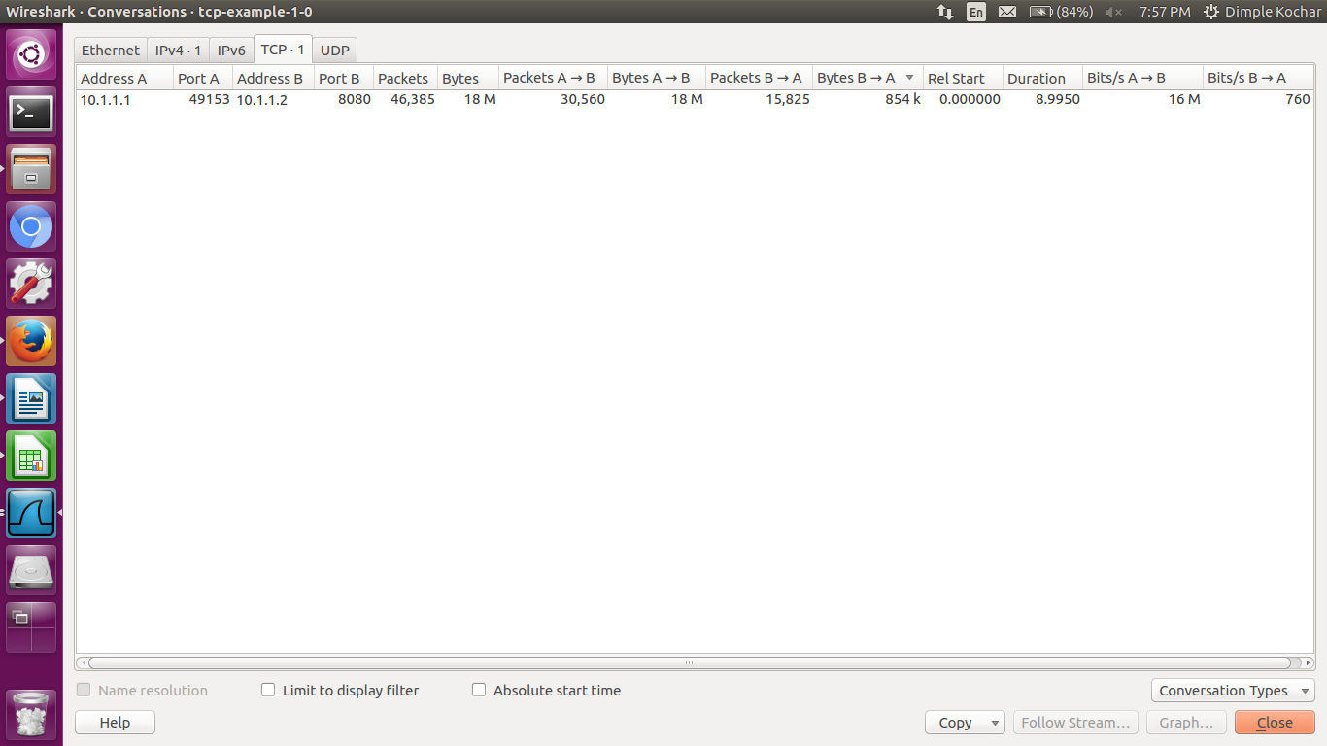
Average throughput=16Mbps

(OR)

On running tshark to get packet length
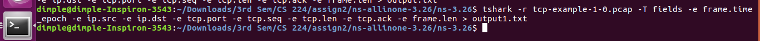
converted output1.txt to spreadsheet output1.ods (attached) and summed all the frame.len column (packet length received column) from 10.1.1.1 to 10.1.1.2=18028012 bytes
Subtracting the last and first time frame to get total time= 8.994982 sec
So throughput is= 18028012/8.994982=2004.229914KBps=16.0338 Mbps

Expected throughput=50Mbps
So, achieved throughput is very less compared to the expected.
This is because 5ms is a high delay for a bandwidth of 50Mbps. If we reduce delay (as shown ahead by a factor of 10), we again get throughput nearly equal to bandwidth.

Case 1) string delay = "5ms"; changing this to "0.5ms"
49Mbps
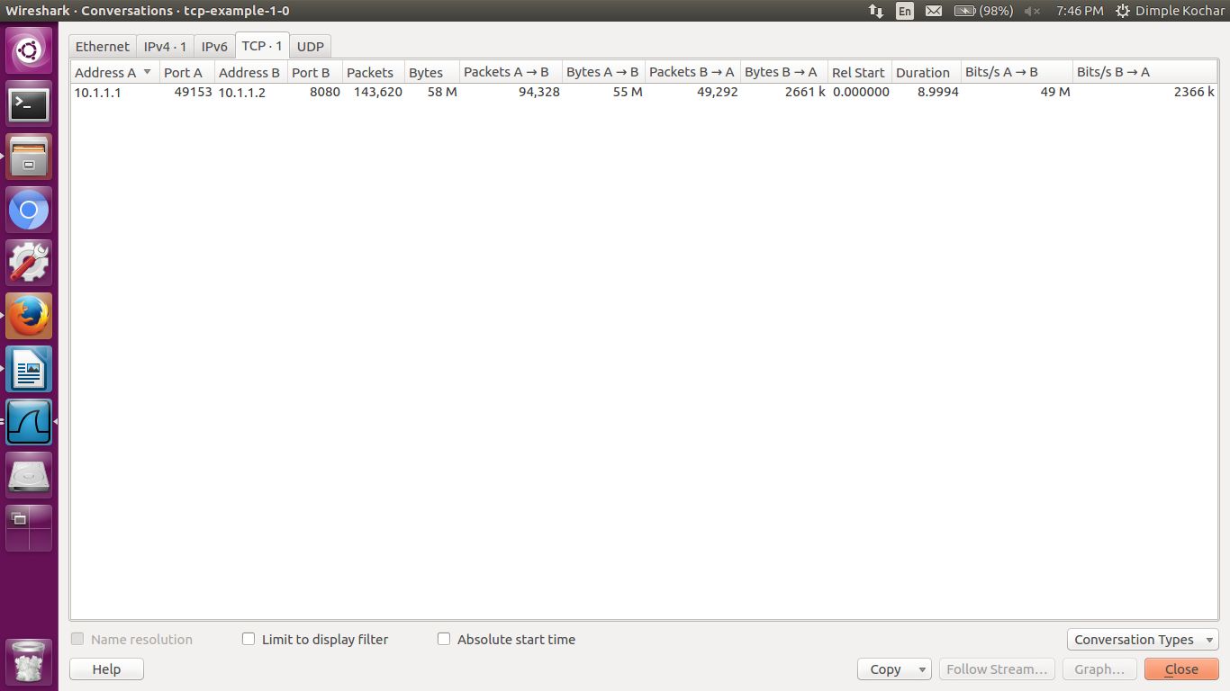

Case 2)
double error_rate = 0.000001; changing this to "0.00000001"
40Mbps
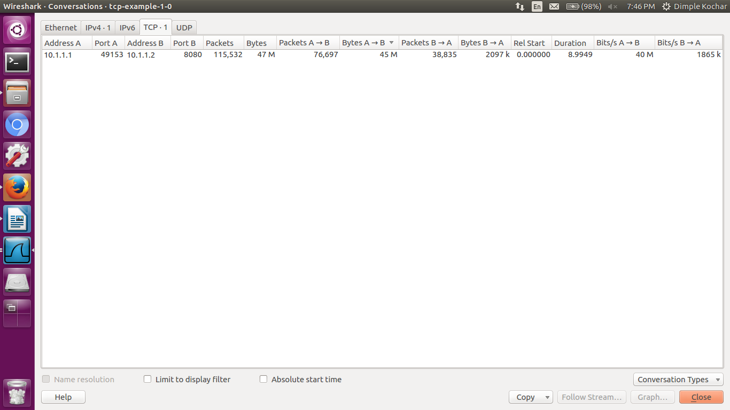

Case 3:
Changing queue size from 10 to 1000 gives less change.
18Mbps

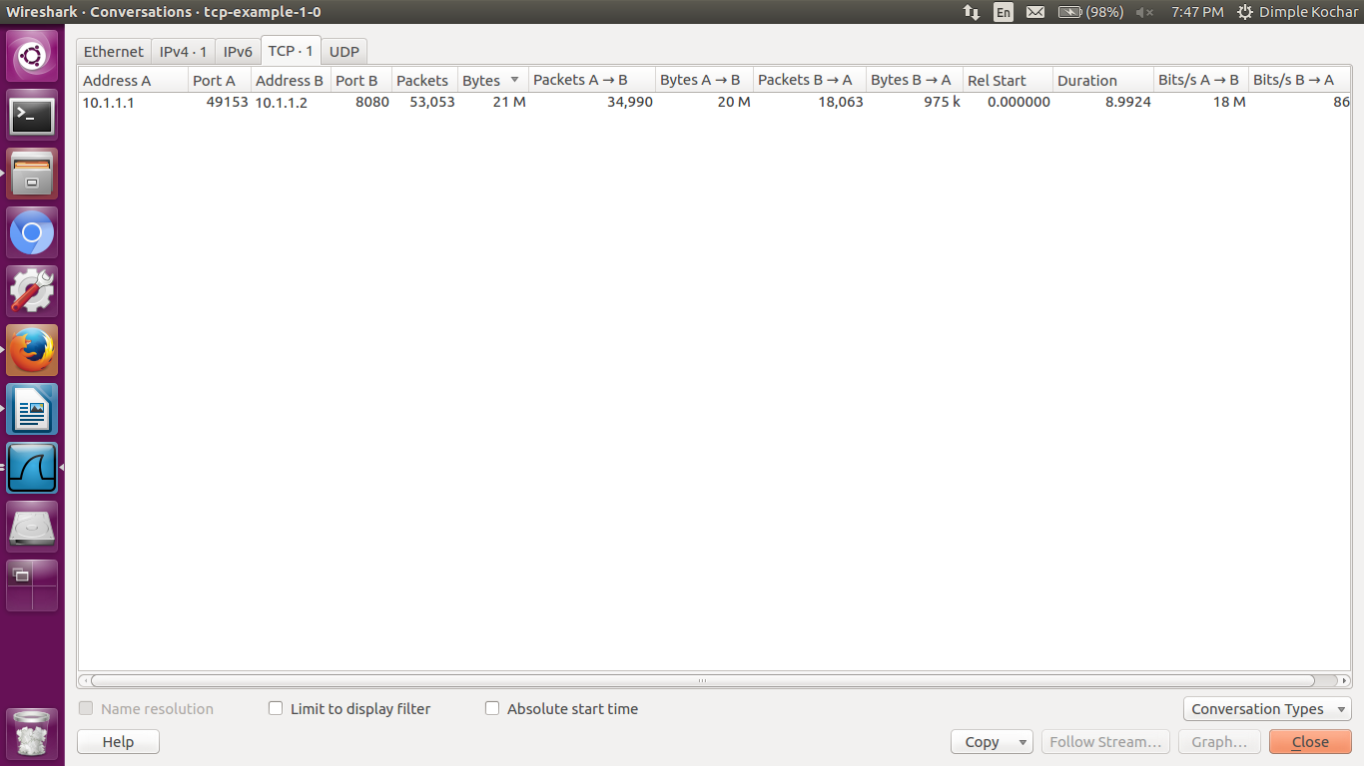

Q3.
Start with the default config. Change the link delay to 50 ms.
- What is the average throughput of the TCP transfer? What is the maximum expected value of throughput? Is the achieved throughput approximately equal to the maximum expected value? If it is not, explain the reason for the difference.
- What other parameters (amongst the ones exposed to you above) can you change to make sure that the throughput is close to the maximum expected value, for this link delay? (Try out a few different simulations, and see what gets you close to the maximum.)
Link delay=50ms

On running tcp-example-1.0.pcap

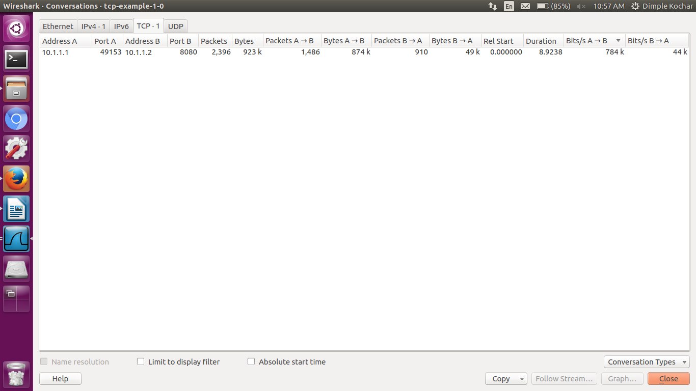

Average throughput= 0.784 Mbps

(OR)

On running tshark to get packet length
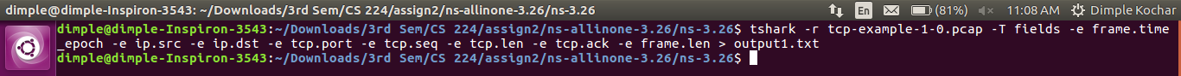

converted output1.txt to spreadsheet output1.ods (attached) and summed all the frame.len column (packet length received column) from 10.1.1.1 to 10.1.1.2=874796 bytes
Subtracting the last and first time frame to get total time= 8.923786 sec
So throughput is= 874796/8.923786=98.02969KBps=0.784237 Mbps

Expected throughput 5Mbps
So, achieved throughput is very less compared to the expected.
This is because 50ms is a high delay for a bandwidth of 5Mbps. If we reduce delay (as shown in Q1 by a factor of 10), we again get throughput nearly equal to bandwidth. Also, due to the high delay, packets get queued up. Since ouroughput queue is small, therefore throughput is lesser.

Case 1) double error_rate = 0.000001; changing this to "0.00000001"
0.784Mbps
No change

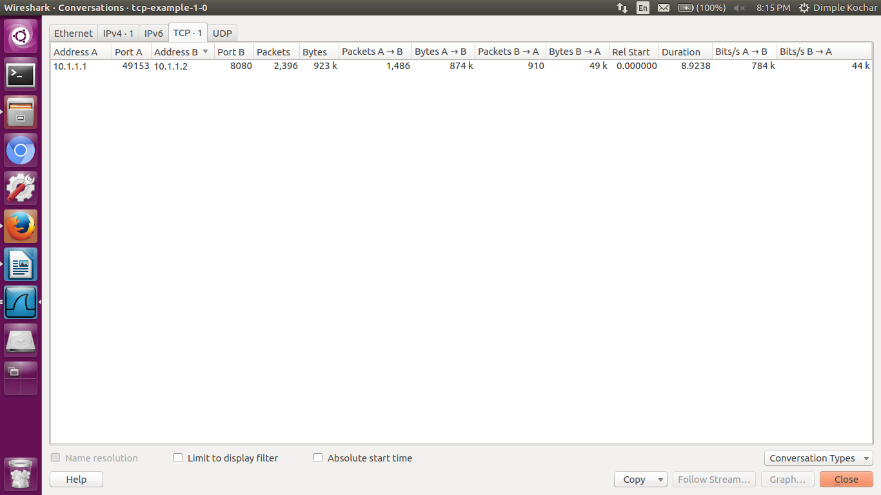

Case 2) int queuesize = 10; //packets
Changing this to 1000 packets
3863 kbps

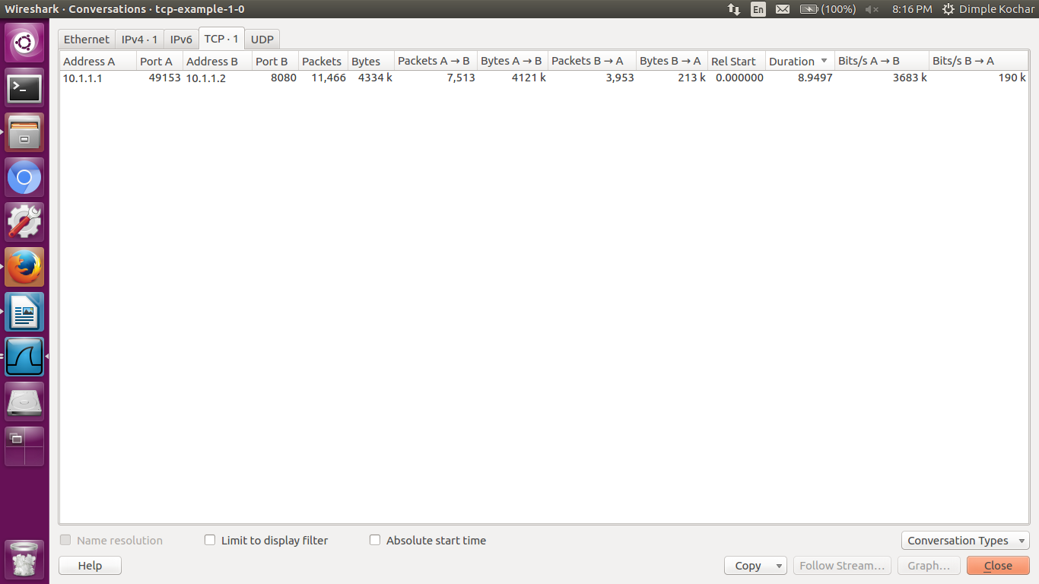

Q4.
Start with the default config. Change the queue size to 1000 packets.
- Compare the TCP throughput in both cases and explain what you see. Further, explain what happens to the queue occupancy, queueing delay, and cwnd in both cases. (If you cannot write scripts to get the queueing delay and queue occupancy, make an educated guess.)
- What is the optimum queue size that must be used in this simulation? Justify your answer.

On running tcp-example-1.0.pcap
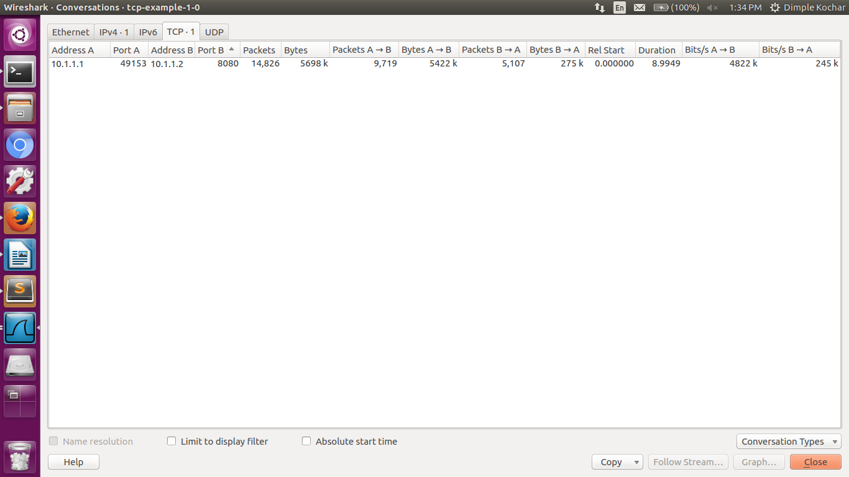

Average throughput=4822Kbps

(OR)

On running tshark to get packet length
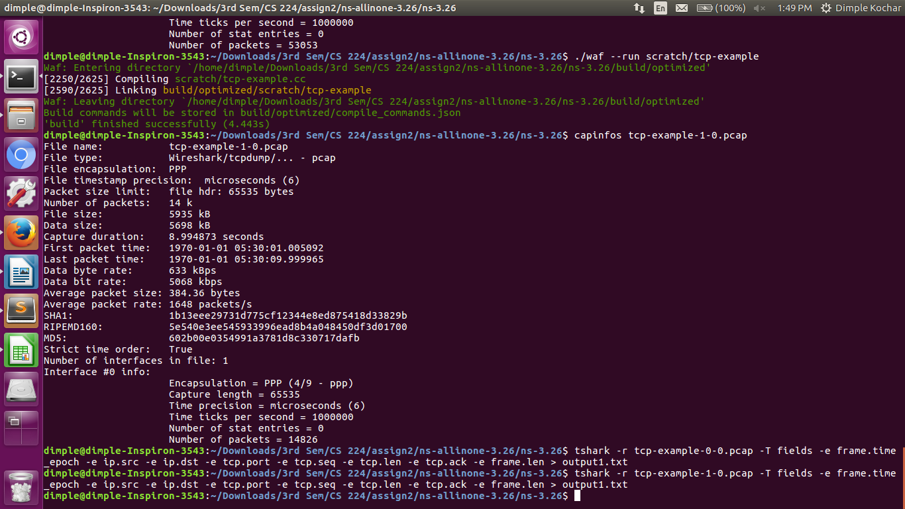
converted output1.txt to spreadsheet output1.ods (attached) and summed all the frame.len column (packet length received column) from 10.1.1.1 to 10.1.1.2=5422750 bytes
Subtracting the last and first time frame to get total time= 8.994873 sec
So throughput is= 5422750/8.994873=602.8712134KBps=4.822969 Mbps

Expected throughput 5Mbps
The achieved throughput is slightly less than that in Q1. as queue length is more, so, comparatively more delay and lesser throughput.

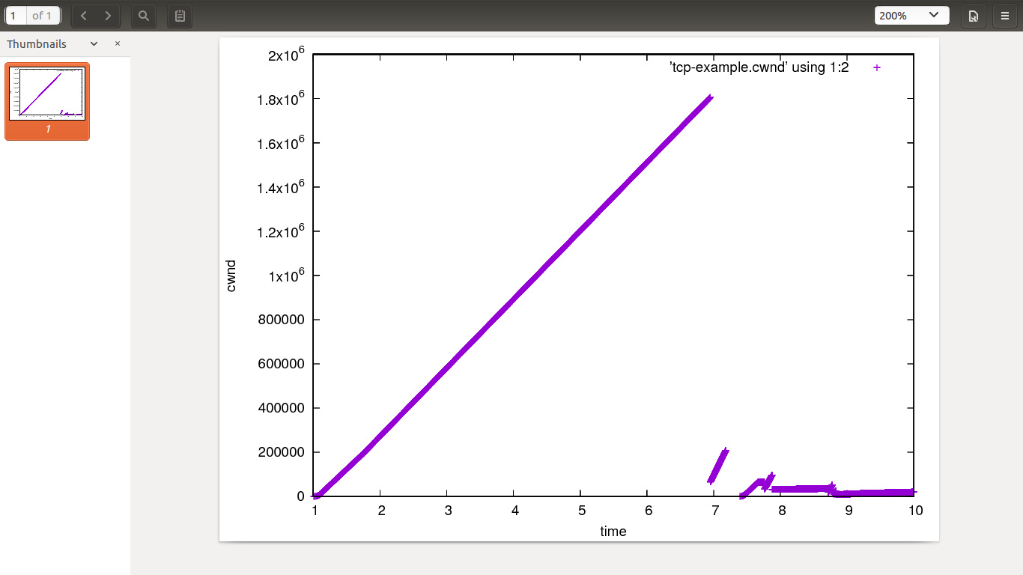

TCP reduced cwnd 5 times.
packet loss happens when window reaches W packets. At this
point, the bottleneck buffer and the pipe have both filled up and so
bottleneck router has dropped a packet. Let the size of bottleneck
buffer be B packets. Let the rate of bottleneck be R and end to end
delay on the path be D. Now BDP = R * D. And W = R * D + B.
Here, R=5Mbps D=5ms So, BDP=25000bits
(Queue=1000) Bottlenext buffer= 1000* 1500*8=12000000bits
Therefore, in the beginning, we get cwnd increasing to 1800000 bits, due to the queue. But there's a packet loss. Later, it's limited by BDP, so, whenever cwnd reaches ~25000bits, there's a packet loss and cwnd is halved.

(Scripts for queuing occupancy (ql.py) and queuing delay (qd.py) attached in Q1. and Q4. folders, along with outputs (ql.txt and qd.txt) and graphs (ql.eps and qd.eps).)

Queue occupancy for queue=1000

Queue occupancy for queue=10

queuing delay for queue=1000

queuing delay for queue=10

When we set queue=1000, we see that at queue~260, we get a non-varying queue length for a certain amount of time. So, ~260 should be the optimum queue length.

